Guidelines for Submitting “Company News” entries for the ISWM News Magazine

The ISWM will include Company News posts for members and member companies using the following guidelines:
All entries will be made on a space available basis and included in the magazine at no charge.
Content must be relevant to the goals and intentions of the ISWM and can include:
- New product announcements
- Announcing significant industry related events
- News about your company employees including significant promotions, retirements and if appropriate, announcements of employees passing.
The text of the news may also include a full color photograph with dimensions of 6.5 mm X 6.5 mm.

Company News Example
- Below is a sample submittal for the Company News. 150 – 200 words is about the right size for text.
IDIMENSION® PLUS WITH OIML APPROVAL
Rice Lake, Wis.—Rice Lake Weighing Systems is excited to announce iDimension Plus now has OIML approval. Rice Lake’s iDimension Plus is the fastest tabletop solution for calculating dimensions of boxes.
OIML approval allows iDimension Plus to be recognized and used in Legal for Trade applications internationally. OIML approval is for measuring parcels in 0.5 or 1 cm increments. iDimension Plus eliminates revenue loss by providing accurate dimensional weight calculations required by parcel and postal carriers. There are configurable modes to measure flats, polybags, tubes and irregular shaped packages for non-approved application in 1 or 2 cm increments.
iDimension Plus measures parcels faster and more accurately than manual measurements, eliminating the risk of human error. It automatically measures parcels and packages in an industry leading 0.2 seconds. iDimension Plus now offers the option of a 4k camera to obtain high resolution image capturing.
To learn more about iDimension Plus and all of Rice Lake’s dimensioning systems, visit www.ricelake.com/idimension
Rice Lake Weighing Systems is a family-owned, ISO 9001 certified corporation, and has been manufacturing and distributing weight-related products and supplies since 1946. Today, Rice Lake Weighing Systems is a global leader in measurement and automated process control.
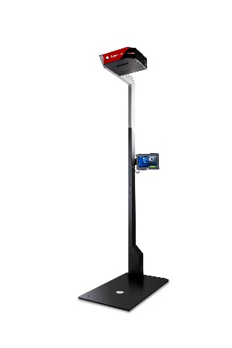We can adapt to some size differences for a different variety of items but the smaller size is our target for the Company News section.

If you have questions about your article or photo please direct these to ann@iswm.org

